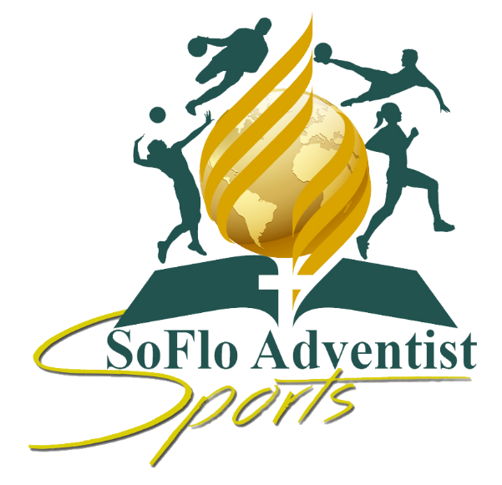
SoFlo Adventist Olympic Games
Sponsorship Package
Dear Future South Florida Adventist Sports Sponsor:
It is a pleasure for us to extend an invitation for your participation in the South Florida Adventist Olympic Games Sponsorship. The SoFlo Committee is part of a non-profit, 501(c) (3), Christian Organization, incorporated in the state of Florida. The SDA organization has been a staple in the South Florida community over 100 years combine and are members of Southeastern Conference of Seventh-day Adventist.

It is our aim to energize the church members and community at large to become more interested in sports activities and by extension health conscious - thus our theme "Promoting a healthy approach to life”. Our goal is to provide environment where anyone can realize his/her full social, intellectual, and athletic potential and develop a strong sense of loyalty, commitment, and appreciation for healthy living. This will be marked by powerful church spirit and pride, superb competition and friendly rivalry and to be credited with the springboard for a healthier community.
Each year, thousands of parents/guardian spends countless hours standing around at ball parks or Track Field watching practices and games. A big part of their time is spent looking around the park - you could call this a captive audience - an advertisers’ dream come true. Why not let our SoFlo advertise for you?
In return for your participation, your Company’s name will be HIGHLIGHTED during our promotions on Social Media, Flyers, Magazine, Group Meetings, Referrals and other platforms. Your sponsorship will earn you and your company the bragging rights of this event. If you would like to become a sponsor of the SoFlo Adventist Games, please complete and submit the Sponsorship Registration Form with your donation to the address below.
Please furnish us with any special requirements or feedback to make this sponsorship possible.
Sincerely yours,

Kenton D. O’Connor
SoFlo Executive Director

Types of Sponsorship packages available:
1. The PLATINUM PLUS SPONSORSHIP
- Display Company‘s banner at Finish Line area. (that you provide)
- Name announced at opening ceremony and during the event
- Display booth of your merchandise/service at the event
- The Champion Trophy will be in your Company’s name. (that you provide)
- Company logo on the back of souvenir t-shirts, above all other sponsors in larger font “Walking Billboards”
- Each athlete on our track team will be given a t-shirt, with your company’s name and/or logo displayed on it. Which they will wear to every track meet that our church attends. “Walking Billboards” (that you provide)
- Special Thank You Plaque with your company’s name, which you can proudly display in your place of business
- Samples and promotional items included in the participant bags (500-700). (that you provide)
- Name on website with link to sponsor’s website and social media mentions
- Full page ad in our souvenir booklet
Complimentary tickets to our award banquet
*The cost of this sponsorship is $6,000 and/or any perks your company may offer.

2. The PLATINUM SPONSORSHIP
- Display Company‘s banner at Finish Line area. (that you provide)
- Name announced at opening ceremony and during the event
- Display booth of your merchandise/service at the event
- Special Thank You Plaque with your company’s name, which you can proudly display in your place of business.
- Name on website with link to sponsor’s website and social media mentions
- Company logo on the back of the souvenir t-shirts, above all other sponsors in larger font
- Samples and promotional items included in the participant bags (500-700)
- Half page ad in our souvenir booklet
*The cost of this sponsorship is $3,500 and/or any perks your company may offer.

2. The GOLD SPONSORSHIP
- Display Company‘s banner at Finish Line area. (that you provide)
- Name on website with link to sponsor’s website and social media mentions
- Name announced at opening ceremony and during the event
- Display booth of your merchandise/service at the event
- Special Thank You Plaque with your company’s name, which you can proudly display in your place of business.
- Company logo on the back of the souvenir t-shirts
- Samples and promotional items included in the participant bags (500-700)
- Quarter page ad in our souvenir booklet
*The cost of this sponsorship is $2,500 and/or any perks your company may offer.

3. The SILVER SPONSORSHIP
- Display Company‘s banner during the event. (that you provide)
- Name on website and social media mentions
- Name announced at opening ceremony and during the event
- Display booth of your merchandise/service at the event
- Special Thank You Plaque with your company’s name, which you can proudly display in your place of business.
- Company logo on the back of the souvenir shirts
- Business card size ad in our souvenir booklet
*The cost of this sponsorship is $1,500 and/or any perks your company may offer.

4. The BRONZE SPONSORSHIP
- Name on website and social media mentions
- Name announced during event
- Name on the back of the race shirts
- Opportunity to have a display booth of your merchandise/service at the event
- Business card size ad in our souvenir booklet
*The cost of this sponsorship is $750 and/or any perks your company may offer.

5. The DONATION/INDIVIDUAL SPONSORHIP
- Sponsor Recognition on our website
*The cost of this sponsorship is $150 and up with any perks you may offer.

SoFlo Sponsorship Package Ad-Souvenir Booklet
Please check one of the packages below:
Our Souvenir Book is a keepsake document handed out and on social media. It reflect the SoFlo experience and have elements of text and pictures. Help make the memories live on by placing an Ad in our special Souvenir Book.

Ad-Souvenir Booklet Rates:
- Inside cover (7 1/2 x 4 7/8) - $200
- Full page (7 1/2 x 4 7/8) - $150
- Half page (3 7/10 x 4 7/8) - $100
- Quarter page (3 7/10 x 2 5/8) - $50
- Eighth page (1 4/5 x 2 5/8) - $35
Deadline for ads: June 1st

__ Platinum PLUS Sponsorship $6,000 & up
__ Platinum Sponsorship $3,500 & up
__ Gold Sponsorship $2,500 & up
__ Silver Sponsorship $1,500 & up
__ Bronze Sponsorship $750 & up
__ Donation/Individual $150

Company Name: __________________________________________________
Contact Person: __________________________________________________
Address: ________________________________________________________
Phone Number: ( ) ______________________ Amount: _____________ Check # _________________
Email/Website Address: _______________________________________________________________
The deadline sponsorship is June 1st. Please make all checks payable to: West Park SDA Church. Kindly complete and return this form along with your sponsorship/Ad Payment to:
West Park SDA Church
“SoFlo Sports”
3825 SW 41st St.
West Park, Florida 33023

If you have any questions please do not hesitate to contact Kenton D. O’Connor at (786)325 2999.
All donations are tax deductible, please contact us for our 501© (3) information.
Please visit our website: www.sofloadventistsports.org

Thank you in advance for your support!
